RESERVATION ENQUIRIES MANAGEMENT SYSTEM

Galileo is the superior and preferred Global Distribution System (GDS) in East Africa and through travel port. It commands the lead in traditional and online travel and leisure booking solutions. Galileo offers the travel agents many tools for airline, car hire, hotels and tours packages. Galileo gives the flexibility to integrate various air and land arrangements into one booking file. Galileo increases its product portfolio by integrating Galileo GDS applications with other tools. An Enquiries System is one of the tools that can be integrated with Galileo GDS to boost the booking process. This tool has a back office, a front office and a communication system that will increase the efficiency and revenue of its clients.

Business Benefits
The Enquiries System will heavily enrich communication and increase efficiency boosting the customer relationship value. This system can also create new revenue streams through service and transaction fees charged to users for such services as flight enquiries and quotations.

Benefits of the Enquiries System include:

- Improve information service delivery to members
- Greater convenience, affordable and more personalized service for members via mobile, Email, and Web.
- Present new business opportunities and new revenue streams from new products
- Provide cheaper and faster channels of communication via mobile networks and the internet
- Saves time and traveling costs on the side of the client
- Improved enquiries management
Features
By using the Enquiries System, Travel Agencies are able to offer their members a number of services. The services include the following:

- Messaging Services:
  - Service notifications
- Flight booking notifications
- Flight fare notifications
- Flight change notifications
  - Promotional notifications
- New travel offers
- A new product or service has been launched
  - Reminder notifications
- Invoice balance payments
- SMS Transactions:
  - Package cost check from database
- Check for fares from Galileo (quotation)
- Check for special package fares from database
- Check balance on account
MODULES
1. Enquiries
This module will handle requests from the clients. The clients will be able to send their requests through three major channels.
- SMS
- Web
- Email
SMS
The client will be able to send a request in form of a Short Message to a specific number provided by the travel agency. The short message should indicate specifically the details of the request.
WEB
The clients will be provided with a web page that they can use to generate their requests. These requests will be sent to the travel agency for processing.
EMAIL
Here the clients will be provided with an email address which they will be able to use to send their requests to the travel agencies.

2. Enquiry allocation

Once the clients have sent their requests, the requests will be received by the travel agency where they will be stored in a central database. The Enquiry Allocation module will enable the travel agency to allocate the enquiry requests received to specific consultants for processing.

3. Enquiry processing

The Enquiry processing module will allow the consultant to process the client requests and give out some response. Once the consultant receives the requests assigned to him/her, the consultant will be expected to process the requests and generate the required response within a specified time period. When the time allocated to the particular requests lapses the requests will be dropped from the consultant and reassigned to another consultant.

3. Response
This Response module will allow the user to generate a response based on the results of the processed requests. The response will be send back to the client who made the request in form of SMS, Web, or Email respectively.

Fig1. Data Flow Diagram
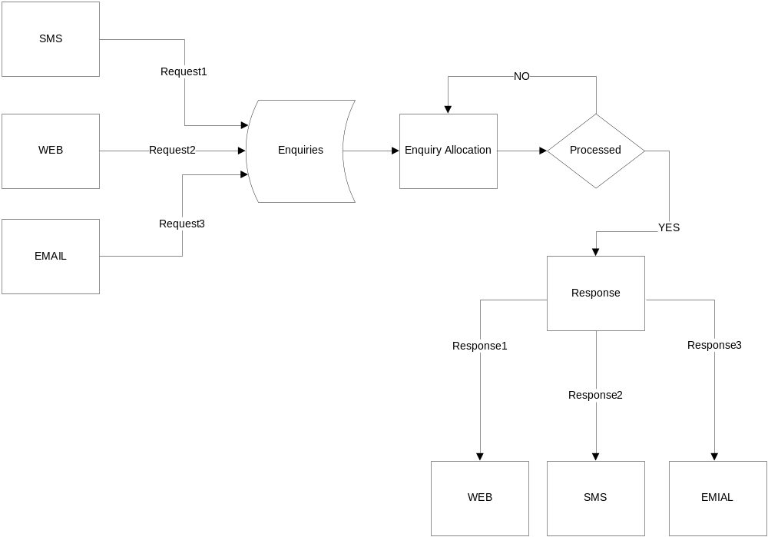
Fig1.
PNR MANAGEMENT SYSTEM

The PNR Management system scans and monitors critical changes to the air itinerary of your and sends alerts either as Short Message Service or as email. It also checks queues for vendor remarks and actions specified tasks like clearing specific queues.

Features
- Email and SMS PNR vendor remarks
- Change alerts are being pushed to email and SMS
- Cost effective communication
- Complete control of the booking file changes
- Alerts in the form of SMS and/or email
- Multiple recipient support
- Send auto alerts to customers using the numbers/mail address stored in the PNR
- Write rules for individual queues
- Write rules for individual airlines
- Easy rule edit function to modify existing rules
- Get notified for specific modifications to the air segments like only cancelled, only time change etc
- Comprehensive user settings to customize the alerts
- Complete logs of email and SMS sent
- Secured password protection for access to the rule page
SERVICE FEES MANAGEMENT SYSTEM

In the 0% and 1% Airline ticket sales commissions the travel agents are under increasing pressure to charge service fees. The service fee needs to be very well managed and standardized so as to be effective and properly charged and collected. Using the Galileo Desktop service fee can be integrated with a service fee tool that will allow the travel agents to add service fees seamlessly into the travel booking process and automate their collection and management.

The tool is a Galileo Desktop system providing a truly end to end solution that will replace the current manual calculation process and leave Galileo connected agencies with more time to spend on taking booking rather than managing back office processes. This tool allows the agents make any comprehensive booking for a flight, safari and hotels among others and compute their respective service fee by a click of a button.

Business Benefits
- The tool is user friendly since it has an easy to use user interface.
- Proper tracking of all service fees charged, invoiced and collected.
- Saves time on processing service fees.
- Any commands that the user needs to execute done by the click of a button making the tool easy to use.
- This tool integrates Galileo with Travcom therefore making management work easier since every details associated with the booking are accurately sent to Travcom for invoicing.
- Minimize the chances of lost revenue due to uncharged or undercharged service charge.

VOUCHER MANAGEMENT SYSTEM

The Hotel Voucher Management System is a web-based system that will be used handle Hotel booking and reservation and to keep track of all the relevant information on the booking. This system is meant to make booking and hotel reservation easy and efficient. Hotel booking and reservation involves a lot of information therefore making it cumbersome for a user to do everything manually. For example this process involves hotels that have numerous rates therefore forcing a user to always check the hotels rates documents whenever he/she has a client. Ideally, this slows down the booking process and errors can also be committed.

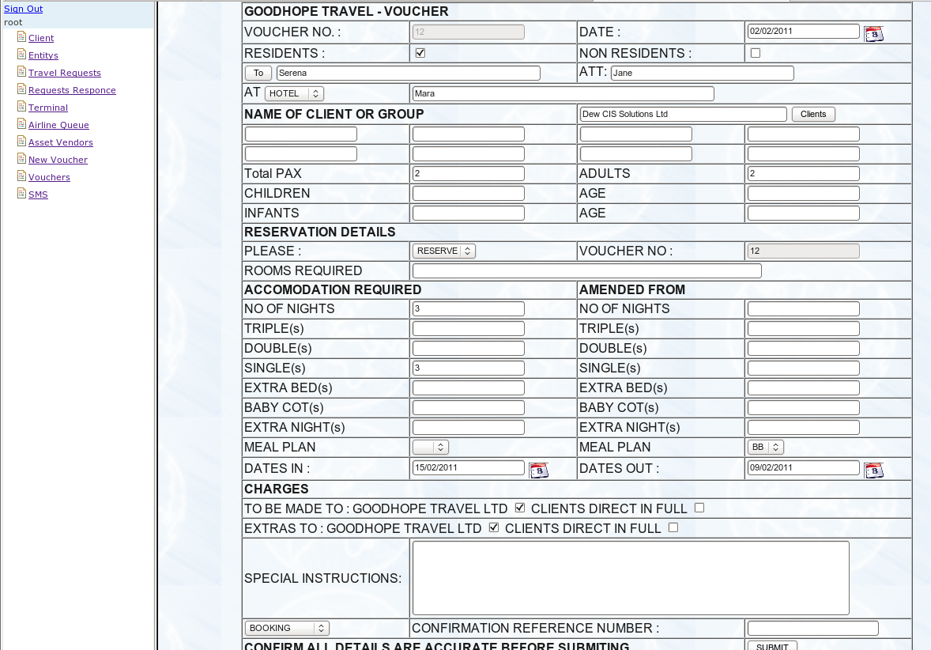

Features
In trying to make the booking process easy, the system has a system configuration section that will keep track of all properties and their rates in the back office and easily present them to the users whenever they want to make a booking. The voucher script will also integrate with Travcom for invoicing purpose.
The voucher script has advantages over the manual hotel booking. The merits include:
- Consultants do not have the hard task of checking their rates every time they do a booking
- User friendly
- Effective since the clients and the vendors are already saved in the system
- Saves time to train new users
- Keeping track of all vouchers and all details of all operations
- Keeps an audit trail to monitor the process
- Automation of the invoicing process
- Security – every user has go to through authentication process to access the system

